9 Important Facts about Florida Landlord-Tenant Law

1. What Questions Can Landlords Ask in a Florida Tenant Screening Background Check?
Landlords in Florida are allowed to check an applicant’s credit history, eviction history, and criminal history with their authorization. However, Florida landlords aren’t allowed to inquire about any of the seven protected classes (race, color, national origin, family status, religion, sex, disability) as outlined by the federal Fair Housing Act. As an alternative, they can ask applicants about the following traits and affiliations under certain conditions:

Age: Landlords can ask about age when it comes to age-specific communities, such as senior housing.
Religious organizations: Landlords can ask about religious organizations if the housing is run by said religious organization.
Club affiliation: Landlords can inquire about one’s private club affiliation if the housing is run by said club and the club doesn’t discriminate against new member applicants.
Florida landlords can also legally deny an application if the applicant fails to meet the criteria — meaning that it’s legal for an applicant to be denied if they have an insufficient income, minimal job history, or unfavorable references from previous landlords.

2. How Much Can Landlords Charge For Security Deposits in Florida?
There’s no limit to the amount a Florida landlord can charge for a security deposit. That being said, every landlord should charge a reasonable amount for a deposit, which is usually between one to three months’ rent depending on if the rental is furnished or unfurnished.

Florida law does state that the landlords must give their tenants a written document detailing the bank account type and where the security deposit is being held within 30 days of receiving it.

3. What Can Be Deducted from a Security Deposit in Florida?
Landlords are allowed to deduct costs for damages that are beyond the normal wear and tear of living in a rental, as is the case in every state. This can include pet damages, neglecting the rental, unauthorized renovations, and more.

Rental property Wear and Tear vs. Damage comparison chart:

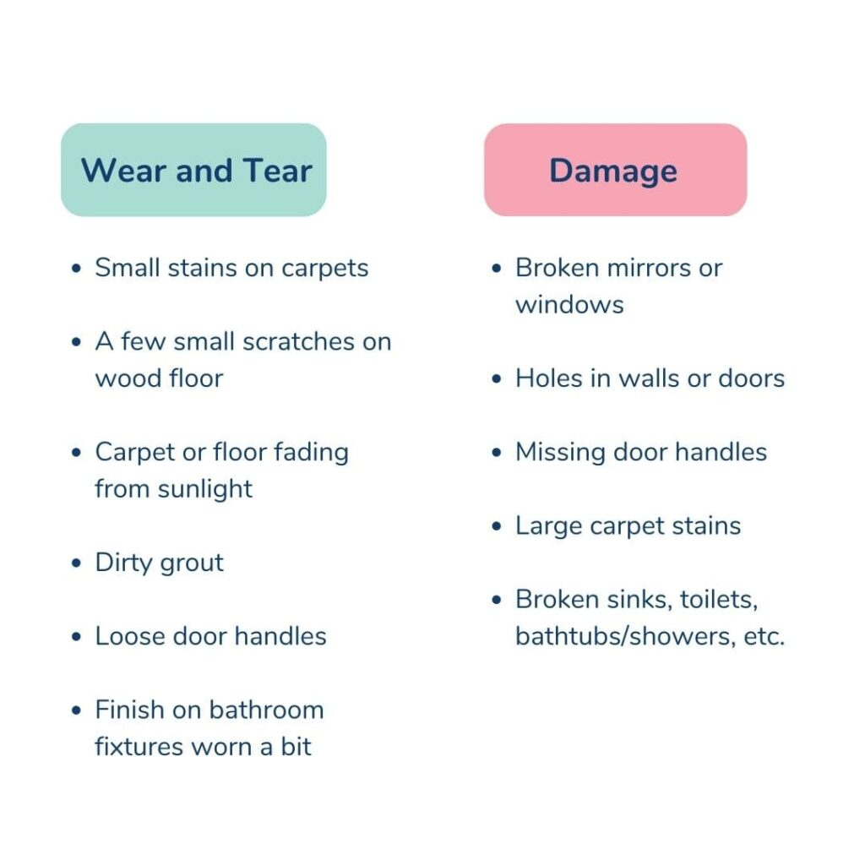
If deductions from the security deposit are necessary, the landlord will have to alert the tenant of such costs within 30 days of the rental move-out date. Tenants also have the right to respond to the notice and contest any deductions within 15 days of receiving the letter.

4. How Much Can a Landlord Raise Rent in Florida?
There’s no limit on how much a landlord can raise the rent on a Florida rental. When planning on increasing the rent price, landlords will need to provide tenants with an advanced written notice stating how much the price will increase, when the new price will be effective, and how tenants can submit their rent payments.

5. How Much Notice Does a Landlord Have to Give for a Rent Increase in Florida?
While there are no specifics on how much notice a Florida landlord needs to give their tenant with a fixed-term lease, a rent increase notice of at least 30 days is fairly standard for fixed-term leases. Florida landlords are also required to give their tenants at least 15 days of notice before the end of a month-to-month lease agreement.

6. What Is the Rent Grace Period in Florida?
Florida does not require a landlord to have a set grace period for rent collection in their lease, but it’s common to give tenants between five to seven days to pay before issuing a non-payment notice. Know that if you have a rent grace period for your rental, it should be written in the rental lease agreement.

If rent isn’t paid within the established grace period, a landlord must send a three-day notice explaining to the tenant that they have three days to either pay rent or move out. If the tenant doesn’t respond to this notice, eviction proceedings can begin after the third day.

7. When Can a Landlord Evict a Tenant in Florida?
Florida landlords are allowed to evict a tenant for issues like breaching their lease terms or failing to pay rent. If the tenant accidentally violated the lease and the issue can be rectified, then Florida law states that the landlord must issue a Seven-Day Notice to Cure, which gives said tenant seven days to fix the issue. If the issue is fixed, the tenant will be able to stay in the property. If it isn’t addressed in the seven-day timeframe, then the landlord is able to carry out eviction proceedings.

8. What Does Florida Landlord-Tenant Law Say About Breaking a Lease?
In a fixed lease, both the landlord and tenant can break the lease early if either party’s rights are infringed upon or if either party breaks an aspect of the lease (not paying rent, refusing to make repairs, etc.). For month-to-month lease agreements, a landlord must give their tenant 15 days’ notice if they want to terminate the lease without legal cause.

There is no legal need for a move-out notice for the end of a lease term unless the lease requires it of the landlord.

9. What Are Tenant Rights in Florida?
There are laws for both landlords and tenants to ensure both parties are protected during the lease term. Here are four main tenant rights set in place that Florida landlords should be aware of:

Right to a private, peaceful possession of the dwelling: Tenants shouldn’t be bothered by their landlord without warning, though landlords are able to address repairs and conduct inspections with reasonable notice of entry.
Security deposit rights: If a tenant proves that deductions made from a security deposit are unnecessary, said tenant may receive the security deposit in full and in some cases gain interest as well.
Withholding rent: Tenants have the right to withhold rent if their landlord is not upholding their duties as written in the lease agreement, such as not maintaining a safe and habitable space. The tenant must give the landlord seven days’ notice of the problem, and if it continues, the tenant has the right to terminate the lease early and move.
No written lease: If there’s no written lease agreement, the tenant has the right to move out for no reason at all as long as they give written notice of their intent to leave.

